**Phase-1 and Phase-2 Documents**

**Team Members:**

* **Bhavitha.G**
* **Sharan.K**
* **Janan.RS**
* **Guruprasaath.D**

**Ideation Phase**

|  |  |
| --- | --- |
| Date | 25-JUNE-2024 |
| Team ID | SWTID1720177025 |
| Project Name | Online Complaint Registration And Management System |
| Maximum Marks | 3 Marks |

**Define the Problem Statements**

**Customer Problem Statement:**

The Online Complaint Registration and Management System aims to streamline the process of submitting, managing, and resolving customer complaints. Customers need an intuitive platform for registering complaints, tracking their status, and communicating with agents. Agents require efficient tools for managing assigned complaints and updating statuses. Admins need comprehensive oversight to monitor complaints, assign tasks, manage user accounts, and continuously improve the platform. The system seeks to enhance user satisfaction and operational efficiency through effective complaint handling and communication

|  |  |  |  |  |  |
| --- | --- | --- | --- | --- | --- |
| **Problem Statement (PS)** | **I am (Customer)** | **I’m trying to** | **But** | **Because** | **Which makes me feel** |
| PS-1 | A customer who wants to lodge a complaint online. | Register a complaint online for a service issue. | The website doesn't have a clear interface for complaint submission. | I cannot find the correct form or procedure. | Frustrated and unable to report my issue effectively. |
| PS-2 | A customer | Track the status of my complaint. | The system doesn't provide real-time updates. | I am left uncertain about the progress of my complaint. | Anxious and uninformed about the resolution timeline. |
| PS-3 | A customer | Receive timely responses to my complaints. | Responses are delayed or non-existent. | I don't know if my complaint has been acknowledged. | Ignored or undervalued as a customer, leading to dissatisfaction. |

**Project Design Phase**

**Proposed Solution Template**

|  |  |
| --- | --- |
| Date | 25 JUNE 2024 |
| Team ID | SWTID1720177025 |
| Project Name | Online Complaint Registration And Management System |
| Maximum Marks | 3 Marks |

**Proposed Solution Template:**

|  |  |  |
| --- | --- | --- |
| **S.No.** | **Parameter** | **Description** |
|  | Problem Statement (Problem to be solved) | The Online Complaint Registration and Management System streamlines the process of handling customer complaints. It provides an easy-to-use platform for customers to submit complaints, track their status, and communicate with agents. Agents get efficient tools to manage and update complaints, while admins have oversight to monitor, assign tasks, and manage user accounts. This system aims to improve customer satisfaction and operational efficiency through effective complaint handling and communication. |
|  | Idea / Solution description | Develop a user-friendly web and mobile platform that allows customers to easily register complaints, track their status in real-time, and communicate directly with assigned agents through an integrated messaging system. Equip agents with a comprehensive dashboard to manage and update complaints efficiently. Provide admins with robust tools for monitoring, assigning tasks, and managing user accounts, ensuring timely resolution and continuous improvement of the platform. This solution will enhance operational efficiency and improve overall user satisfaction. |
|  | Novelty / Uniqueness | Our solution excels with seamless real-time communication and status tracking, providing instant updates and direct customer-agent interaction. The user-friendly design simplifies complaint handling, while intelligent assignment ensures expert handling. Admin oversight ensures continuous improvement, maintaining a secure and efficient system that surpasses traditional methods. |
|  | Social Impact / Customer Satisfaction | Our system boosts customer satisfaction through transparent, efficient complaint resolution. Real-time updates and direct agent communication make customers feel valued, fostering trust and engagement. It reduces frustration, enhances user experience, and promotes accountability within organizations, strengthening community relationships. |
|  | Business Model (Revenue Model) | Generate revenue through tiered subscription plans for businesses and agents, transaction fees per complaint, and customization services. Offer premium support packages, sell detailed analytics and insights, and provide advertising opportunities. Additionally, offer white-label solutions for organizations seeking a branded version of the platform. This diversified approach ensures steady income while delivering enhanced value to customers and businesses |
|  | Scalability of the Solution | The Online Complaint Registration and Management System is designed to scale effortlessly with growing user demands. Cloud-based infrastructure ensures reliable performance and data security, even with increasing volumes of complaints and user interactions. Modular architecture allows easy integration of new features and third-party services, facilitating continuous enhancement. Advanced data analytics and machine learning capabilities enable automated complaint categorization and intelligent assignment, improving efficiency as the user base expands. This scalable design ensures the platform can adapt to varying business sizes and industry needs, supporting long-term growth and widespread adoption. |

**Project Planning Phase**

**Project Planning Template (Product Backlog, Sprint Planning, Stories, Story points)**

|  |  |
| --- | --- |
| Date | 25 JUNE 2024 |
| Team ID | SWTID1720177025 |
| Project Name | Online Complaint Registration And Management System |
| Maximum Marks | 4 Marks |

**Product Backlog, Sprint Schedule, and Estimation (2 Marks)**

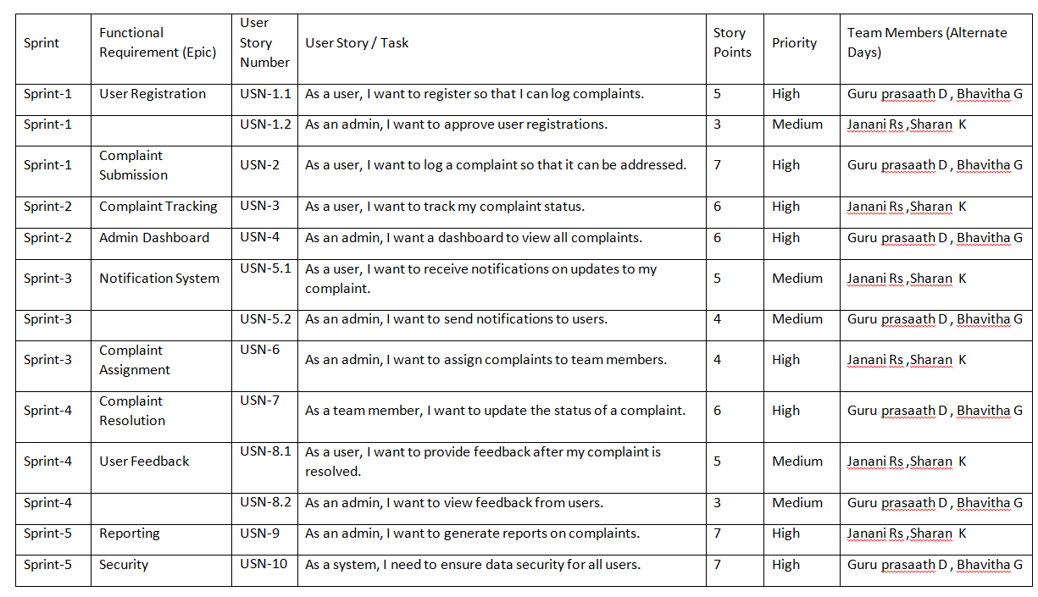

**Product Backlog, Sprint Schedule, and Estimation (2 Marks)**

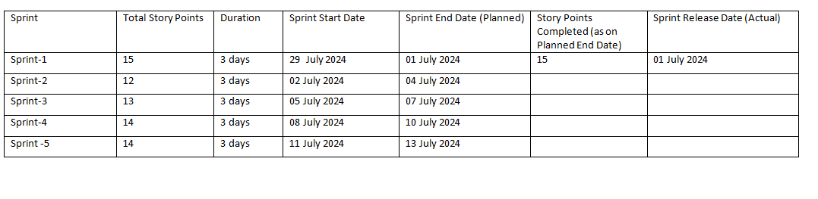

**Velocity:**

|  |  |
| --- | --- |
| Sprint | Average Velocity (story points/Duration) |
| Sprint-1 | 15/3=5 |
| Sprint-2 | 12/3=4 |
| Sprint-3 | 13/3=4.3 |
| Sprint-4 | 14/3=4.6 |
| Sprint-5 | 14/3=4.6 |

Total story points=75 story points

**Burndown Chart:**

A burndown chart is a graphical representation of work left to do versus time. It is often used in agile[software development](https://www.visual-paradigm.com/scrum/what-is-agile-software-development/) methodologies such as [Scrum](https://www.visual-paradigm.com/scrum/scrum-in-3-minutes/). However, burn down charts can be applied to any project containing measurable progress over time.

<https://www.visual-paradigm.com/scrum/scrum-burndown-chart/>

<https://www.atlassian.com/agile/tutorials/burndown-charts>

**Reference:**

<https://www.atlassian.com/agile/project-management>

<https://www.atlassian.com/agile/tutorials/how-to-do-scrum-with-jira-software>

<https://www.atlassian.com/agile/tutorials/epics>

<https://www.atlassian.com/agile/tutorials/sprints>

<https://www.atlassian.com/agile/project-management/estimation>

<https://www.atlassian.com/agile/tutorials/burndown-charts>

**Requirement Gathering and Analysis Phase**

**Solution Requirements (Functional & Non-functional)**

|  |  |
| --- | --- |
| Date | 04-JULY-2024 |
| Team ID | SWTID1720177025 |
| Project Name | Online Complaint Registration And Management System |
| Maximum Marks |  |

**Functional Requirements:**

Following are the functional requirements of the proposed solution.

|  |  |  |
| --- | --- | --- |
| **FR No.** | **Functional Requirement (Epic)** | **Sub Requirement (Story / Sub-Task)** |
| FR-1 | User Registration | Registration through Form  Registration through Gmail  Registration through LinkedIn |
| FR-2 | User Confirmation | Confirmation via Email  Confirmation via OTP |
| FR-3 | Complaint Submission | Submission Form  Attach files  Categorize complaint |
| FR-4 | Real-Time Tracking | Track status of complaint  Receive updates |
| FR-5 | Messaging System | Integrated chat with assigned agent  Notification for new messages |
| FR-6 | Agent Dashboard | View assigned complaints  Update status  Communication with customers |
| FR-7 | Admin Panel | Monitor system performance  Assign tasks to agents  Manage user accounts |
| FR-8 | Analytics and Reporting | Generate performance reports  Continuous improvement suggestions |

**Non-functional Requirements:**

Following are the non-functional requirements of the proposed solution.

|  |  |  |
| --- | --- | --- |
| **FR No.** | **Non-Functional Requirement** | **Description** |
| NFR-1 | **Usability** | User-friendly and intuitive interfaces |
| NFR-2 | **Security** | Data encryption and secure authentication |
| NFR-3 | **Reliability** | High availability and fault tolerance |
| NFR-4 | **Performance** | Fast response times and real-time updates |
| NFR-5 | **Availability** | System uptime and accessibility |
| NFR-6 | **Scalability** | Handle increasing user load |

**Requirement Gathering and Analysis Phase**

**Solution Architecture**

|  |  |
| --- | --- |
| Date | 04-JULY-2024 |
| Team ID | SWTID1720177025 |
| Project Name | Online Complaint Registration And Management System |
| Maximum Marks |  |

**Solution Architecture:**

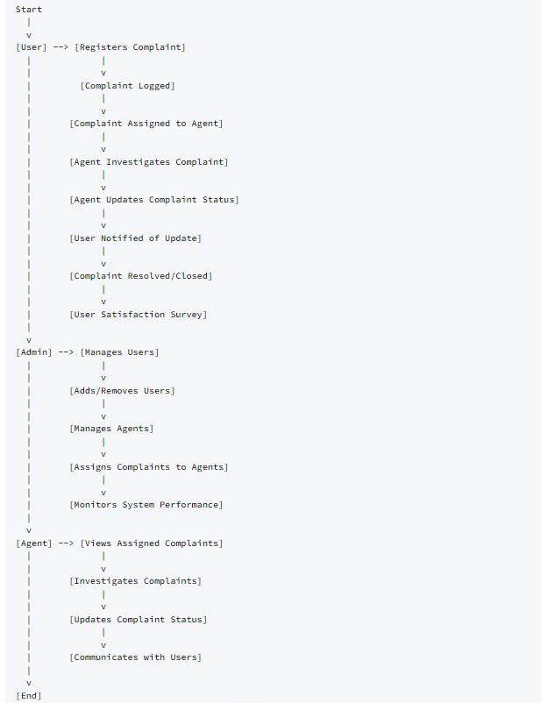

**Customer Role:**

1. **Register Complaint:**
   * **Start:** Customer begins the process by accessing the complaint registration interface.
   * **Enter Details:** Provides necessary information such as complaint title, description, and contact details.
   * **Submit:** Registers the complaint into the system.
2. **View Complaint Status:**
   * **Start:** Customer navigates to the complaint status section.
   * **Select Complaint:** Chooses a specific complaint from the list.
   * **View Status:** Checks the current status of the selected complaint (e.g., Pending, In Progress, Resolved).
3. **Update Contact Information:**
   * **Start:** Customer accesses the profile or settings section.
   * **Modify Information:** Updates personal contact details like email address or phone number.
   * **Save Changes:** Confirms and saves the updated contact information in the system.

**Admin/Support Staff Role:**

1. **View Complaints:**
   * **Start:** Admin logs into the system and accesses the admin dashboard.
   * **View List:** Reviews a comprehensive list of all complaints currently registered in the system.
2. **Assign Complaint:**
   * **Select Complaint:** Chooses a specific complaint from the list.
   * **Assign to Staff:** Assigns the selected complaint to a designated support staff member for handling.
   * **Confirm Assignment:** Updates the system to reflect the assignment status of the complaint.
3. **Update Complaint Status:**
   * **Start:** Admin selects a complaint that requires status update.
   * **Update Status:** Changes the status of the complaint based on its progress (e.g., from Pending to In Progress, Resolved).
4. **Communicate with Customer:**
   * **Start:** Admin selects a complaint and accesses the communication interface.
   * **Compose Message:** Drafts a message or update regarding the complaint's progress or additional information required.
   * **Send Message:** Sends the message to the customer associated with the complaint.

**Agent:**

1. **Agent Investigates Complaint**:

* The agent looks into the details of the complaint, gathers necessary information, and takes steps to address the issue.

1. **Agent Updates Complaint Status**:

* As the agent works on the complaint, they update the status to reflect the current stage of the resolution process.

1. **User Notified of Update**:
   * The system sends notifications to the user about any changes in the status of their complaint.

**Requirement Gathering and Analysis Phase**

**Technology Stack (Architecture & Stack)**

|  |  |
| --- | --- |
| Date | 04-JULY-2024 |
| Team ID | SWTID1720177025 |
| Project Name | Online Complaint Registration And Management System |
| Maximum Marks |  |

**Technical Architecture:**

The Deliverable shall include the architectural diagram as below and the information as per the table1 & table

**Title/Project:** **Online Complaint Registration and Management System**

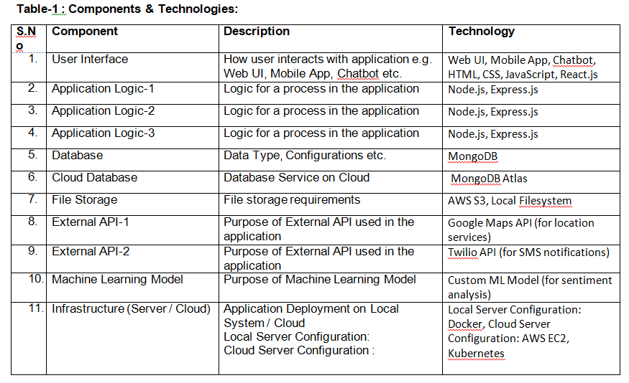

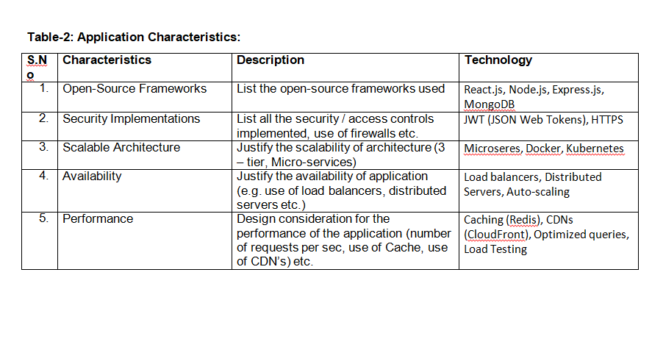

**Requirement Gathering and Analysis Phase**

**Data Flow Diagram & User Stories**

|  |  |
| --- | --- |
| Date | 04-JULY-2024 |
| Team ID | SWTID1720177025 |
| Project Name | Online Complaint Registration And Management System |
| Maximum Marks |  |

**Data Flow Diagrams:**

A Data Flow Diagram (DFD) is a traditional visual representation of the information flows within a system. A neat and clear DFD can depict the right amount of the system requirement graphically. It shows how data enters and leaves the system, what changes the information, and where data is stored.

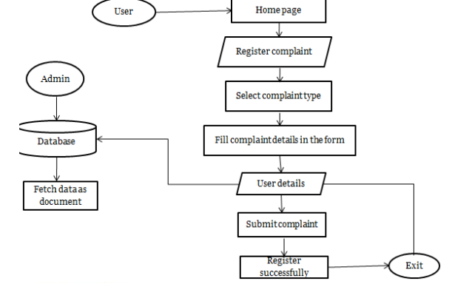

**User Stories**

Use the below template to list all the user stories for the product.

|  |  |  |  |  |  |  |
| --- | --- | --- | --- | --- | --- | --- |
| **User Type** | **Functional Requirement (Epic)** | **User Story Number** | **User Story / Task** | **Acceptance Criteria** | **Priority** | **Release** |
| Customer (Mobile user) | Registration | USN-1 | As a user, I can register for the application by entering my email, password, and confirming my password. | I can access my account / dashboard | High | Sprint-1 |
|  |  | USN-2 | As a user, I will receive confirmation email once I have registered for the application | I can receive confirmation email & click confirm | High | Sprint-1 |
|  |  | USN-3 | As a user, I can register for the application through Facebook | I can register & access the dashboard with Facebook Login | Low | Sprint-2 |
|  |  | USN-4 | As a user, I can register for the application through Gmail | I can register & access the dashboard with Gmail Login | Medium | Sprint-1 |
|  | Login | USN-5 | As a user, I can log into the application by entering email & password | I can access my account / dashboard | High | Sprint-1 |
|  | Dashboard | USN-6 | As a user, I can view and manage my complaints from the dashboard | I can see my complaints and their status | High | Sprint-1 |
| Customer (Web user) | Registration | USN-7 | As a user, I can register for the application by entering my email, password, and confirming my password | I can access my account / dashboard | High | Sprint-1 |
|  |  | USN-8 | As a user, I will receive confirmation email once I have registered for the application | I can receive confirmation email & click confirm | High | Sprint-1 |
|  |  | USN-9 | As a user, I can register for the application through Facebook | I can register & access the dashboard with Facebook Login | Low | Sprint-2 |
|  |  | USN-10 | As a user, I can register for the application through Gmail | I can register & access the dashboard with Gmail Login | Medium | Sprint-1 |
|  | Login | USN-11 | As a user, I can log into the application by entering email & password | I can access my account / dashboard | High | Sprint-1 |
|  | Dashboard | USN-12 | As a user, I can view and manage my complaints from the dashboard | I can see my complaints and their status | High | Sprint-1 |
| Customer Care Executive | Dashboard | USN-13 | As a customer care executive, I can view and manage complaints assigned to me | I can see assigned complaints and update their status | High | Sprint-1 |
|  | Messaging | USN-14 | As a customer care executive, I can communicate with customers through an integrated messaging system | I can send and receive messages from customers | High | Sprint-1 |
| Administrator | User Management | USN-15 | As an administrator, I can manage user accounts (create, update, delete) | I can add, update, or remove user accounts | High | Sprint-1 |
|  | Task Assignment | USN-16 | As an administrator, I can assign complaints to customer care executives | I can assign complaints to specific executives | High | Sprint-1 |
|  | System Monitoring | USN-17 | As an administrator, I can monitor the performance of the system | I can see system performance metrics | Medium | Sprint-1 |
|  | Reporting | USN-18 | As an administrator, I can generate reports on system performance and complaint resolution | I can generate and download performance reports | Medium | Sprint-2 |
|  |  |  |  |  |  |  |
|  |  |  |  |  |  |  |
|  |  |  |  |  |  |  |